CS 499 Module One Assignment Template

Complete this template by replacing the bracketed text with the relevant information.

- Self-Introduction: Address all of the following questions to introduce yourself.

  - How long have you been in the Computer Science program?

I have been in the Computer Science program for about three years now.

  - What have you learned while in the program? List three of the most important concepts or skills you have learned.

Three of the most important skills I have learned during this program would be coding fundamentals, software development lifecycles, and how to interact with and interpret data using various programs like SQL or Power BI.

  - Discuss the specific skills you aim to demonstrate through your enhancements to reach each of the course outcomes.

The specific skills I would like to demonstrate would be coding knowledge, problem solving ability, and critical thinking skills.

  - How do the specific skills you will demonstrate align with your career plans related to your degree?

I have not decided a specific career plan; however the above skills would be applicable to any area of work I pursue in this field of degree.

  - How does this contribute to the specialization you are targeting for your career?

Coding fundamentals, problem solving, and critical thinking skills will aid me in being a strong team member. I have a fundamental knowledge that can be built on and specialized in a wide variety of development careers, and problem-solving capabilities that will help me in assuring the quality of my work. Finally, critical thinking is paramount to any career, being able to assess a situation and address it critically allows for me to provide meaningful insights to my coworkers.

- ePortfolio Set Up:

  - Submit a screen capture of your ePortfolio GitHub Pages home page that clearly shows your URL.
    - You already have a repository in GitHub where you uploaded projects in previous courses. Your ePortfolio will reside in GitHub but can link to work at other sites, such as Bitbucket.

  - Use the GitHub Pages link in the Resource section for directions on:
    - How to create your GitHub website and publish code to GitHub Pages
    - Issues, such as adding links to other sites

  - Paste a screenshot of your GitHub Pages home page with your URL clearly showing in the space below.
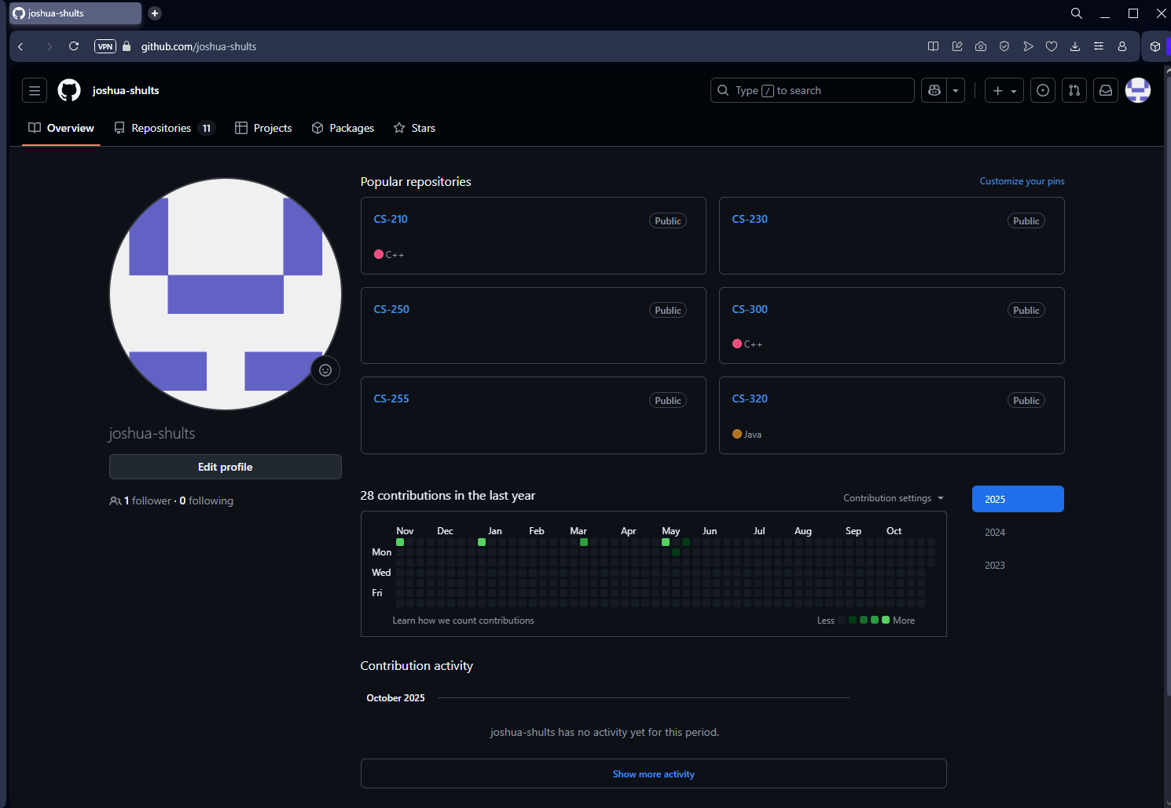
(Above: my GitHub home page, https://github.com/joshua-shults)

- Enhancement Plan:

  - Category One: Software Engineering and Design
    - Select an artifact that is aligned with the software engineering and design category and explain its origin. Submit a file containing the code for the artifact you choose with your enhancement plan.

Note: Your artifact may be work from the following courses:

- IT 145: Foundation in Application Development
- CS 250: Software Development Lifecycle
- CS 260: Data Structures and Algorithms
- IT 315: Object Oriented Analysis and Design
- CS 320: Software Testing, Automation, and Quality Assurance
- CS 330: Computational Graphics and Visualization
- CS 340: Advanced Programming Concepts
- CS 350: Emerging Systems Architectures and Technologies
- CS 360: Mobile Architecture and Programming
- IT 365: Operating Environments
- IT 380: Cybersecurity and Information Assurance
- CS 405: Secure Coding
- CS 410: Reverse Software engineering
- IT 340: Network and Telecommunication Management
- IT 380: Cybersecurity and Information Assurance

    - Describe a practical, well-illustrated plan for enhancement in alignment with the category, including a pseudocode or flowchart that illustrates the planned enhancement.

The project I am enhancing comes from CS 320, Software Testing, Automation, and Quality Assurance. The original program was only made to test restrictions on classes, such as a task containing no more than 50 characters. My proposed enhancement to the program would be adding in a main function that provides a UI to a user to actually enter in contacts, appointments, and tasks. Contacts, appointments, and tasks will also need to be related to one another, and all entries should be stored in a file that the program can read and write from. Below is a flowchart for how I plan on this enhancement to work.

[Start]
|
v
[Load files if present/Create file if not]
|
v
[Show Main Menu]
|
+--> (Contacts) -----------+
|
| +-->(Add Contact)----+-->[Validate]->[Create]->[Confirm]->(Back)
| +-->(List Contacts)-------->[Display]->[Display Appointments/Tasks for this contact]
->[Back]
| +-->(View/Edit)------------>[Select]->[Edit]->[Update]->(Back)
| +-->(Delete)--------------->[Select]->[Delete]->(Back)
|
+--> (Appointments) ------ similar CRUD to contact, appointments are related to contact
|
+--> (Tasks) ------------- Same CRUD, Tasks are related to contacts
|
+--> (Save) -------------->[Write to files]->(Back)
|
+--> (Load) -------------->[Confirm overwrite]->[Read file]->(Back)
|
+--> (Exit) -------------->[Continue? Y/N]->[End]

For this category of enhancement, consider improving a piece of software, transferring a project into a different language, reverse engineering a piece of software for a different operating system, or expanding a project’s complexity. These are just recommendations. Consider being creative and proposing an alternative enhancement to your instructor.

Think about what additions to include to complete the enhancement criteria in this category. Since one example option is to port to a new language, that is the kind of scale that is expected. This does not mean you need to port to a new language but instead have an equivalent scale of enhancement. Underlying expectations of any enhancement include fixing errors, debugging, and cleaning up comments, but these are not enhancements themselves.

    - Explain how the planned enhancement will demonstrate specific skills and align with course outcomes.

      - Identify and describe the specific skills you will demonstrate that align with the course outcome.
The planned enhancements I have for this previous project will demonstrate my skills in software development, data management, and problem-solving abilities. This work will take a program with no functionality beyond testing into a real, usable program that could be used for taking down information and creating appointments. Areas that will remain the same in the project will show my methods of quality assurance in a program.

      - Select one or more of the course outcomes below that your enhancement will align with.

The course outcome that my enhancement aligns with is 4, demonstrating my ability to implement computer solutions that deliver value and accomplish goals.

Course Outcomes:

- Employ strategies for building collaborative environments that enable diverse audiences to support organizational decision-making in the field of computer science.
- Design, develop, and deliver professional-quality oral, written, and visual communications that are coherent, technically sound, and appropriately adapted to specific audiences and contexts.
- Design and evaluate computing solutions that solve a given problem using algorithmic principles and computer science practices and standards appropriate to its solution while managing the trade-offs involved in design choices.
- Demonstrate an ability to use well-founded and innovative techniques, skills, and tools in computing practices for the purpose of implementing computer solutions that deliver value and accomplish industry-specific goals.
- Develop a security mindset that anticipates adversarial exploits in software architecture and designs to expose potential vulnerabilities, mitigate design flaws, and ensure privacy and enhanced security of data and resources.

  - Category Two: Algorithms and Data Structures

- Select an artifact that is aligned with the algorithms and data structures category and explain its origin. Submit a file containing the code for the artifact you choose with your enhancement plan. You may choose work from the courses listed under Category One.

The artifact I have chosen for this category is the weight tracker app I made in CS-360: Mobile Architecture and Programming. The app itself is a simple solution for users to monitor their goal weights without too many additional features. The program aligns with this category as it stores data in weight entries as well as user login information.

- Describe a practical, well-illustrated plan for enhancement in alignment with the category, including a pseudocode or flowchart that illustrates the planned enhancement.

The plan I have for enhancing this application is to add a feature that calculates the user’s average weight changes over time, and with this estimate their progress toward their goal weight. This will demonstrate the use of algorithms and data structures to make the app much more useful.
This feature will use an Array List to store weight entries by date. The app will then iterate through the list to calculate the average daily weight and use that information to estimate how many days will remain until the target weight is reached. I will also add a new tile to the mobile application that displays this information and sends updates to the user if they accept them.
Pseudocode
FUNCTION calculate progress (user ID):
Weight <- get all weights from user
Sort weights by date
IF weight size is less than 2 entries:
RETURN “Not enough data to calculate progress.”

Total Change <- 0
FOR i FROM 1 TO Weights Size – 1:
Daily Change <- Weight[i] – Weight[i – 1]
Total Change <- total change + daily change
Average Change Per Day <- total change / (weight.size – 1)
Remaining <- current weight – goal weight

IF average change per day == 0:
RETURN “No progress yet”
Estimated days <- abs( remaining / average change per day )
RETURN “Estimated days to goal: “ = estimated days

For this category of enhancement, consider improving the efficiency of a project or expanding the complexity of the use of data structures and algorithms for your artifact. These are just recommendations. Consider being creative and proposing an alternative enhancement to your instructor. Note: You only need to choose one type of enhancement per category.

Think about what additions to include to complete the enhancement criteria in this category. Since one example option is to port to a new language, that is the kind of scale that is expected. Perhaps you might increase the efficiency and time complexity of an algorithm in an application and detail the logic of the increased time complexity. Remember, you do not need to port to a new language but instead have an equivalent scale of enhancement. Underlying expectations of any enhancement include fixing errors, debugging, and cleaning up comments, but these are not enhancements themselves.

- Explain how the planned enhancement will demonstrate specific skills and align with course outcomes.

  - Identify and describe the specific skills you will demonstrate to align with the course outcome.

  - Select one or more of the course outcomes listed under Category One that your enhancement will align with.

The skills I will demonstrate is my ability to improve upon prior existing code, along with my ability to critique my own designs in order to improve them. The course outcome that this aligns with is 3, design and evaluate computing solutions that solve a given problem using algorithmic principles and computer science practices and standards appropriate to its solution while managing the trade-offs involved in design choices.

  - Category Three: Databases

    - Select an artifact that is aligned with the databases category and explain its origin. Submit a file containing the code for the artifact you choose with your enhancement plan. You may choose work from the courses listed under Category One.

I will be using the same artifact from Category One for this category. Though the program I made for that course was simply to do JUNIT testing, the framework is there for me to add a main program to take in information, which can be stored in a database.

    - Describe a practical, well-illustrated plan for enhancement in alignment with the category, including a pseudocode or flowchart that illustrates the planned enhancement.

My plan for enhancing this artifact involves integrating a MySQL database to persist all user data for appointments, contacts, and tasks. This will demonstrate my knowledge of database design, data persistence, and functional relationship building skills. I will create three relational tables for each class, contacts, appointments, and tasks. Each table will have a unique ID as the primary key and use foreign key relationships for linking appointments and tasks to their respective contacts. The program will connect to MySQL through Java Database Connectivity to allow the user to perform CRUD operations.
Pseudocode
FUNCTION Connect To Database:
Load JBDC
Get Connection (DB_URL, USER, PASSWORD)
RETURN Connected
FUNCTION Add Contact:
Sql <- “INSERT INTO Contacts (contactID, firstName, etc.)
EXECUTE sql with the contact data
FUNCTION View Contacts:
Sql <- “SELECT ___ FROM Contacts” # depending on what the user enters
Results <- EXECUTE query (sql)
RETURN results
FUNCTION Add Appointment:
Sql <- “INSERT INTO Appointments (AppointmentID, ContactID, Date, etc.) VALUES (???)
EXECUTE sql with the appointment data
FUNCTION Add Task:
Sql <- “INSERT INTO Tasks (TaskID, Contact ID, etc) VALUES (???)
EXECUTE sql with task
Flow Chart
[Start]
|
V
[Connect to database]
|
V
[Display Menu]
|
V
[Add Contact] ------------->[Insert Into Contacts Table]
|
V
[View Contacts] ----------->[SELECT ___ FROM Contacts]
|
V
[Delete Contact]----------->[DELETE ____ FROM Contacts]
|
V
[Add Appointment]------>[Insert Into Appointment Table]
|
V
[Delete Appointment]--->[DELETE ___ FROM Appointment]
|
V
[Add Task]------------------->[Insert Into Tasks]
|
V
[Delete Task]--------------->[DELETE ___ FROM Tasks]
|
V
[Delete Contact]------------>[DELETE FROM Contacts, Appointments, Tasks WHERE ID = ?]

For this category of enhancement, consider adding more advanced concepts of MySQL, incorporating data mining, creating a MongoDB interface with HTML/JavaScript, or building a full stack with a different programming language for your artifact. These are just recommendations; consider being creative and proposing an alternative enhancement to your instructor. Note: You only need to choose one type of enhancement per category.

Think about what additions to include to complete the enhancement criteria in this category. Since one example option is to port to a new language, that is the kind of scale that is expected. Perhaps you might increase the efficiency and time complexity of an algorithm in an application and detail the logic of the increased time complexity. Remember, you do not need to port to a new language but instead have an equivalent scale of enhancement. Underlying expectations of any enhancement include fixing errors, debugging, and cleaning up comments, but these are not enhancements themselves.
    - Explain how the planned enhancement will demonstrate specific skills and align with course outcomes.

      - Identify and describe the specific skills you will demonstrate that align with the course outcome.

I will be demonstrating my skills in database design and implementation, SQL knowledge, data management, and software integration.

      - Select one or more of the course outcomes listed under Category One that your enhancement will align with.

This enhancement will align with outcomes 4 and 5. I will be demonstrating my ability to use innovative techniques, skills, and tools in computing practices to deliver value and achieve goals. I will also be developing a security mindset regarding implementing a role based access system to determine who is able to perform specific CRUD operations based on the credentials they pass into my program.

- ePortfolio Overall Skill Set

  - Accurately describe the skill set to be illustrated by the ePortfolio overall.
    - Skills and outcomes planned to be illustrated in the code review

The code review will illustrate my technical knowledge considering software development. I will showcase my ability to write code that is of good structure, has maintainability, and follows industry standards that I have learned during my time in these courses.

    - Skills and outcomes planned to be illustrated in the narratives

My narrative will be tailored to explaining the rationale behind the enhancements I will be adding to my previously developed programs. In my narrative I will also explain any challenges I faced and how I used my problem-solving skills to deliver a final, enhanced software.

    - Skills and outcomes planned to be illustrated in the professional self-assessment

The professional self-assessment will demonstrate my capability for honest self-reflection and subsequent growth. I will be honest in my self-assessment in areas I need to continue to improve, as well as how I plan to continue doing so in the future.

